

Timesheet X Supervisor Guide

Time sheets must now be entered online for all NUNM Work Study jobs.

Getting started….

The online timesheet process starts AFTER the student applies for a hire form (www.nunm.edu) and after it is signed by both student and supervisor and handed in. You will be notified by email once you are approved to begin filling out a timesheet.

**Please note: Be sure to check your junk mail or spam folder for emails from Nelnet/Timesheet X. Change your email filter if this is the case.**

When you receive the email notification that you are approved…….

1. Open: http://nunm.studentemployment.ngwebsolutions.com
2. Once on the page, click on Employees.

3. Then click Time Sheet Management Log In

**IF you are a returning log in supervisor, you will then be prompted to login once you arrive at the site.

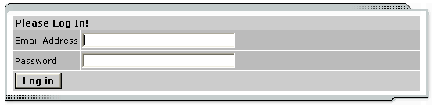

4. IF THIS IS YOUR FIRST TIME LOGGING IN TO THE SITE:
Click ‘Logging in for first time?’ below the log in box.

a. You will need to type in your email address and click ‘Submit’.
**Please Note: Use the email address that the school has on
file for you** For most staff and faculty, your email address is the first initial of your first name and your full last name@nunm.edu)

b. Next, open your email account and an email will be waiting for you with a link to set a new password. Your password is “nunm” until you login and change it. We strongly encourage you to change your password ASAP.

To Do Items
TimesheetX will automatically load the To-Do Items page after the user logs in. (It can also be accessed from the TimesheetX menu TimesheetX > TimesheetX Employer Home (To Do). All time sheets presented on this page require immediate attention.

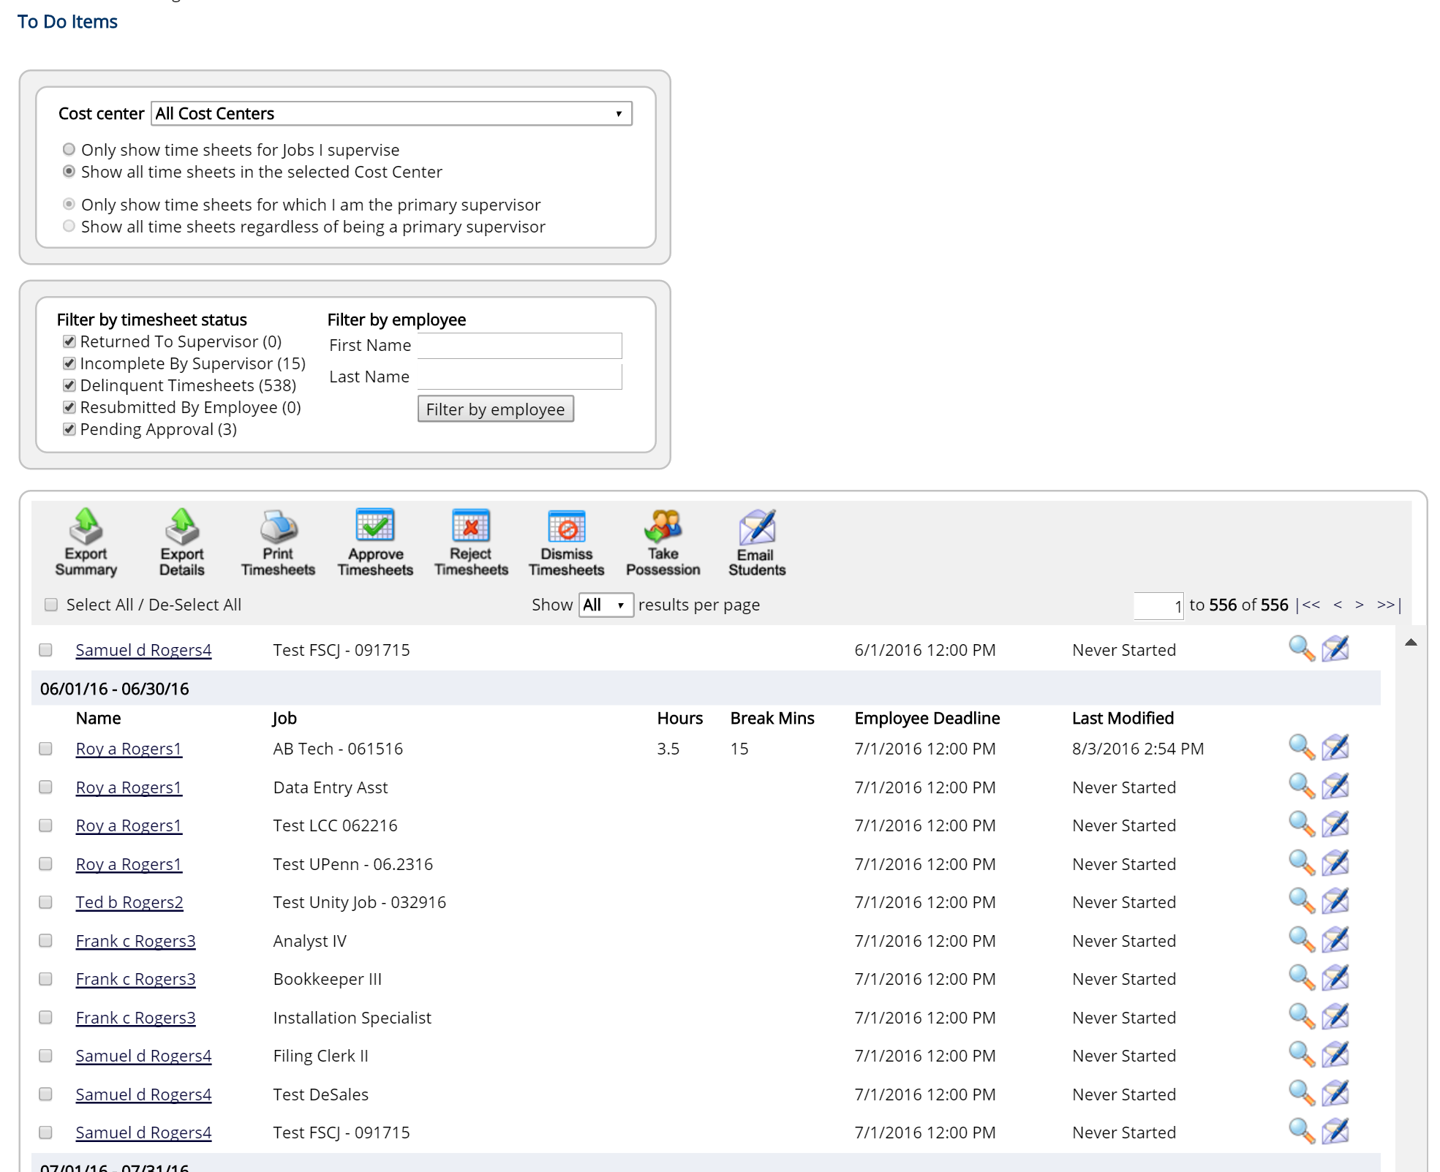

Time sheets can be organized under five possible categories:
- Returned to Supervisor – These time sheets have been reviewed by an administrator and returned to you. A note attached to each time sheet will explain why the time sheet is returned, and you must resolve the problem before resubmitting it to an administrator for approval. To review the time sheet details, either hover over the magnifying glass or click the magnifying glass to manage the time sheet individually.
- Incomplete by Supervisor – These are time sheets begun by a supervisor that have not been completed. Once a time sheet is begun by a supervisor, it cannot be edited by an employee, thus a supervisor must complete it. To review the time sheet details, either hover over the magnifying glass or click the magnifying glass to manage the time sheet individually.
- Delinquent Timesheets – These time sheets may or may not have been started by employees (as indicated in the Last Modified column); regardless, they were never submitted for approval, and the employee deadline has passed. To send an individual e-mail reminder to the employee or to take control of a specific time sheet, click the magnifying glass.
- Resubmitted by Employee – These are time sheets revised and resubmitted by employees for your approval. They must be approved by the deadline listed next to them.
- Pending Approval – These time sheets have been completed by employees and submitted for your review. They must be approved by the deadline listed next to them.

note 1: Only those categories currently with time sheets to display will appear on the To-Do Items page. For example, if there are no delinquent time sheets, that particular table will not display.
note 2: If you’d like to manage multiple time sheets in a particular status at one time, simply click the box next to each time sheet you wish to manage and then click on the specific icon of the function you wish to complete.
 Below is a legend of icons and corresponding mass time sheet functions.

 | Export Summary – This function will provide high level time sheet details you see on the screen for those time sheets selected. |  | Export Details – This function will provide detailed time sheet entries into an excel spreadsheet for those time sheets selected.
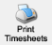 | Print Timesheets – This function will provide a user friendly print version for those time sheets selected. | 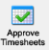 | Approve Timesheets – This function will enable the Supervisor to approve those time sheets selected as long as the time sheet(s) are in a status that can be approved.
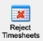 | Reject Timesheets - This function will enable the Supervisor to reject those time sheets selected as long as the time sheet(s) are in a status that can be rejected. | 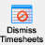 | Dismiss Timesheets - This function will enable the Supervisor to dismiss those time sheets selected as long as the time sheet(s) are in a status that can be dismissed.
 | Take Possession - This function will enable the Supervisor to take possession of those time sheets selected as long as the time sheet(s) are in a status that can be rejected.

 Change Departments
If you supervise employees in multiple departments, you will have a drop-down menu at the top of the To-Do Items page. When you select a different department, the page will reload and display the to-do items for that department’s time sheets. Be sure to get in the habit of checking the To-Do Items for all the departments that you manage.

 Warnings
Administrators may want to alert you to particular situations through the use of warnings. If you receive a warning, it will display at the top of your To-Do Items page in a salmon-colored box.

This warning pictured above is alerting you to the fact that one of your employees, Chad Billmyer, has worked too many hours. If a warning has a next to the title, please hover your mouse over it for instructions on how to resolve the warning.

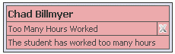

Manage Delinquent Time Sheets
When an employee’s time sheet is delinquent, you have two options: 1) you can e-mail the employee to remind him or her to submit it or 2) you can take hold of the time sheet -- revoking employee access -- and finish it yourself. By clicking the magnifying glass next to the delinquent time sheet on the To-Do Items page, you can access both functions.

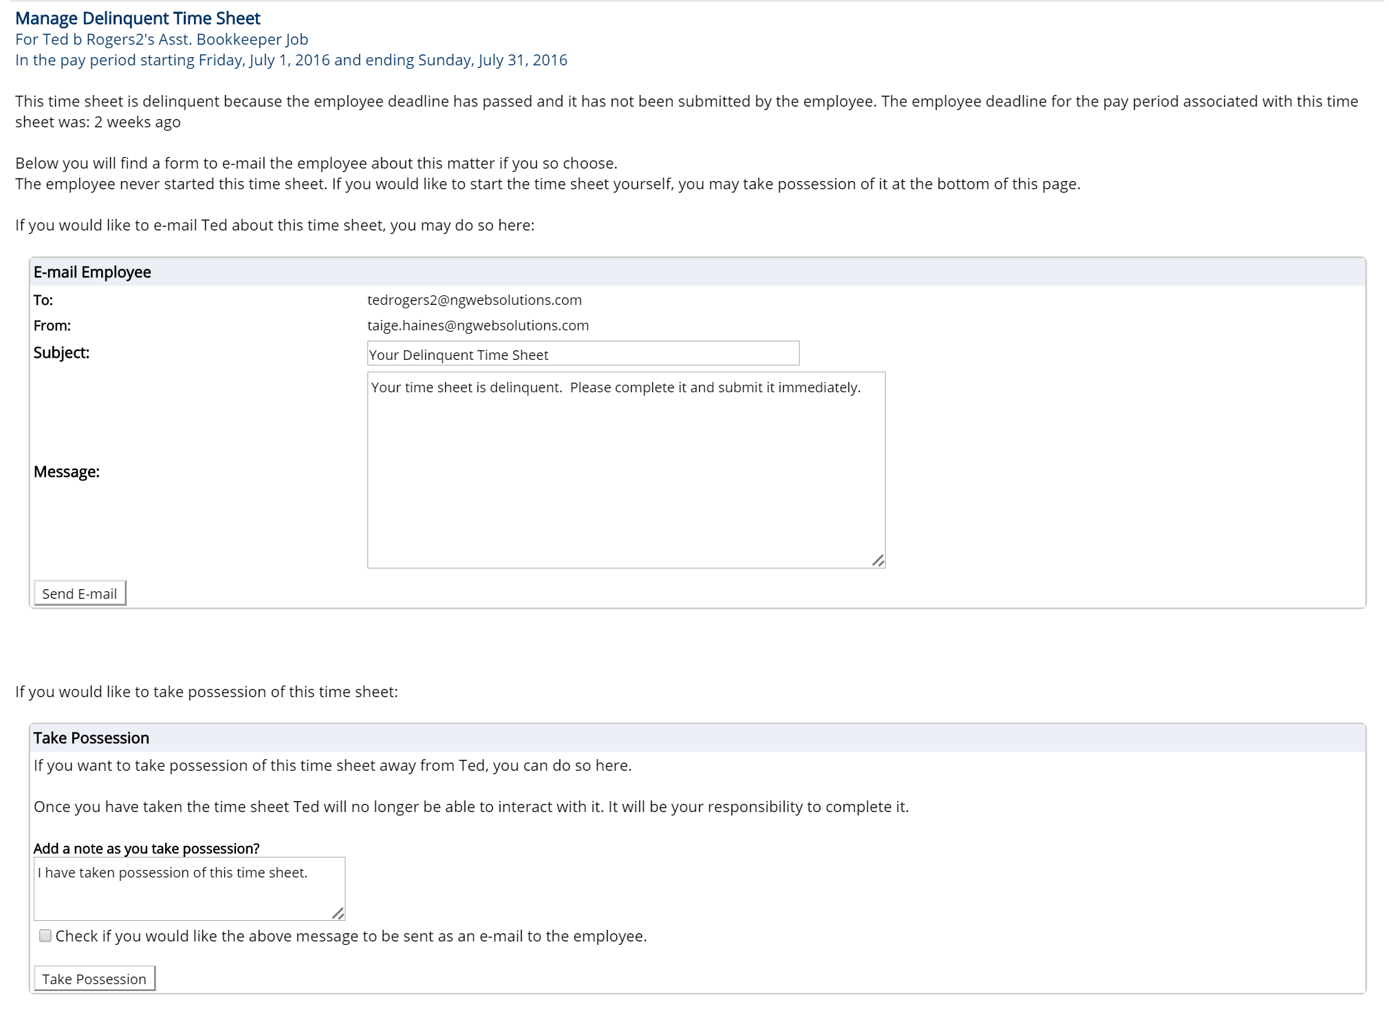

The top section of this page allows you to send a reminder e-mail to the employee. Edit the subject and body of the message, then click Send E-mail.

To take possession of the time sheet, click Take Possession from the bottom section of the page. Place a check mark just above the button if you would like to accompany the action with an e-mail to the employee. You can revise the body of the e-mail in the small text box. Once you click Take Possession, the time sheet will load and you can revise it as you wish. (See the Manage Time Sheet section of this document for more information.)

My Control Panel

Unlike the To-Do Items page, which displays only the jobs and time sheets demanding immediate attention, Timesheet Control Panel allows you access to all jobs for which you are the primary or secondary supervisor, regardless of whether they are in need of attention. Timesheet Control Panel is also the place to locate past time sheets.

Click TimesheetX > Timesheet Control to access the My Control Panel function.

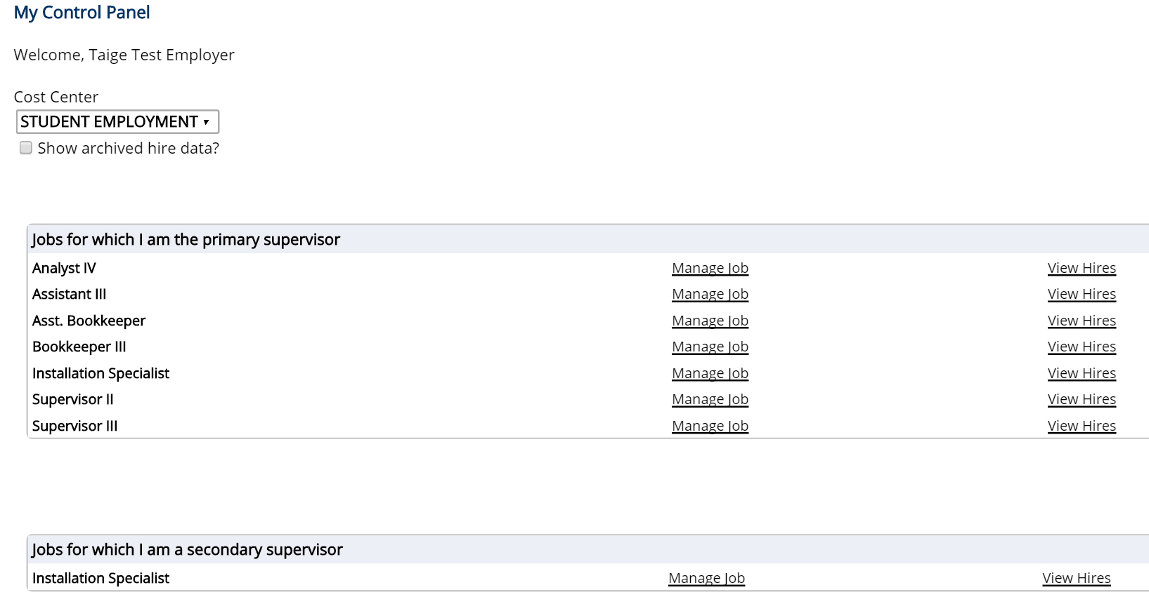

Click Manage Job to change the title or description of the job.

When you select View Hires, a list of your employees for that job will open:

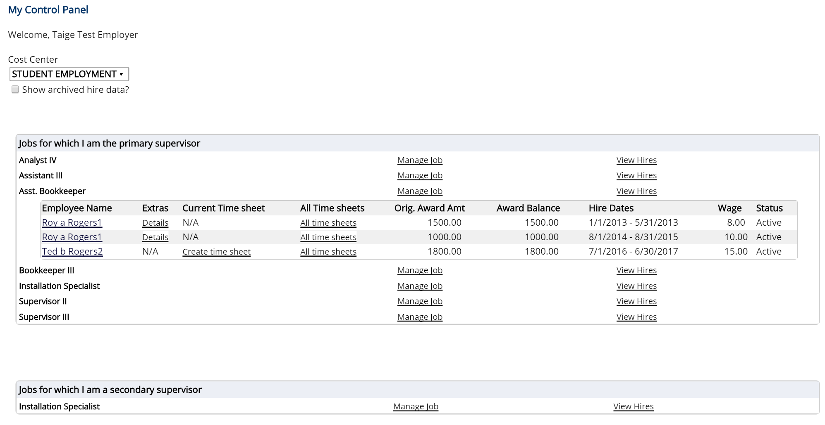

Next to each employee are additional functions. Hover your mouse over Details and a status update will appear, including any potential delinquent time sheets.

Click Go to Time Sheet to access to current time sheet that is pending approval.

To view a history of this employee’s time sheets, click All Time Sheets. A new window will load in which you can view the detail of every past time sheet. For those past time sheets still in need of approval or revision, All Time Sheets will also provide you that functionality.

Manage Time Sheet
The Manage Time Sheet page cannot be accessed directly from the TimesheetX menu. Instead, it appears only when you try to access a specific time sheet.

Information will appear differently, or not all, depending on the status of the time sheet and your permission level.

For instance, when the time sheet is in the employee’s possession the only information available will be the status and pay period details. The entries and action options would not appear.

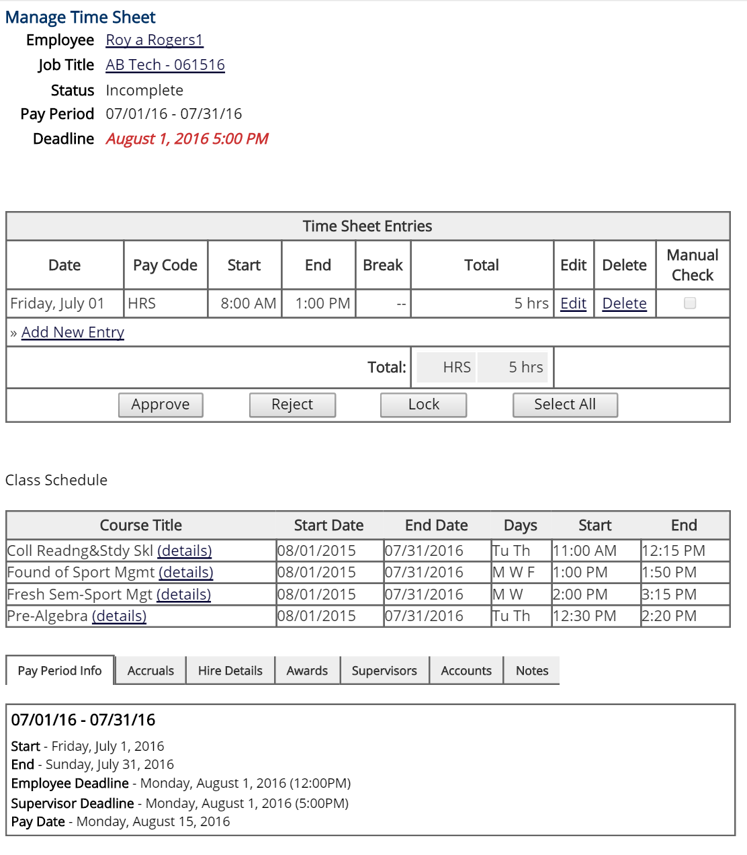

Depending on your permissions, some of the time sheet management options may not appear. To take action on a time sheet, the supervisor must select one of the action buttons (e.g. Approve, Reject, Lock, Select All). If a time sheet has already been paid outside of TimesheetX, click on the ‘Manual Check’ box for next to the time sheet entry to prevent a duplicate payment from being made. If your institution does not utilize this feature, this column will not be present on this screen.

The top section of the page informs you of the time sheet’s status and important dates. Deadline refers to the date by which you must approve this time sheet and submit it to an administrator.

Carefully review the employee’s time entries before you approve them.

Click the Notes tab to make a manual note or review audit related notes created by the system. Notes are viewable by administrators, other supervisors, and employees. Notes remain attached to a time sheet through the admin approval process and are retained even after a pay period is finalized.

Search & View Student Awards and Class Schedules

To search and/or view Student Award and Class Schedule data, click the TimesheetX > Search Student Awards and Class Schedules function.

1 Enter the Employee’s Last Name or Employee ID.
2 Click their name returned in the Search Results box.

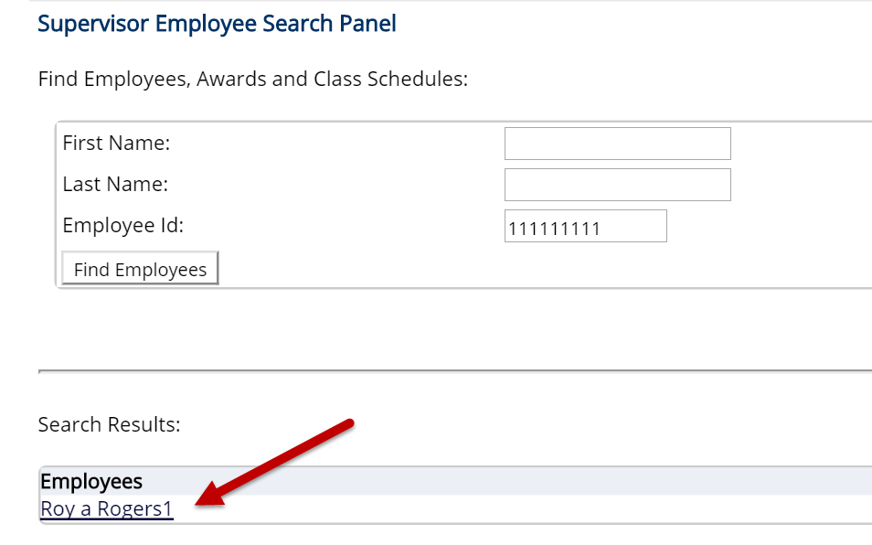

If the Employee has any current awards or Class Schedules loaded to TimesheetX, they will be presented as follows:

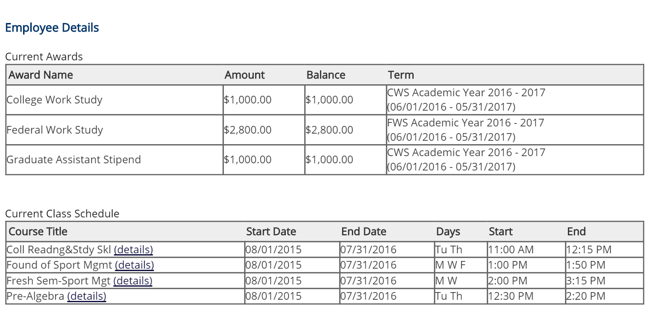

Budget Manager – Budget Details

If your institution utilizes the TimesheetX Budget Manager function to proactively prevent departmental budget overspend situations, Supervisors may be granted access to monitor their own cost center/departmental budgets.

In order to review your cost center/departmental budget information, navigate to the TimesheetX menu and click the Budget Details function. Select the current budget period you wish to review from the Budget drop down list.

This screen will present your cost center/departmental Current Budget, Actual Earnings spent against that budget, and Actual Remaining Budget Balance. Additionally, this page will inform you of a threshold that has been set, if any.

If the Actual Remaining Budget amount goes below a set threshold, a systematic email and/or screen notification will be initiated if checks appear in the ‘Email?’ or ‘Screen?’ boxes next to the department’s budget details.

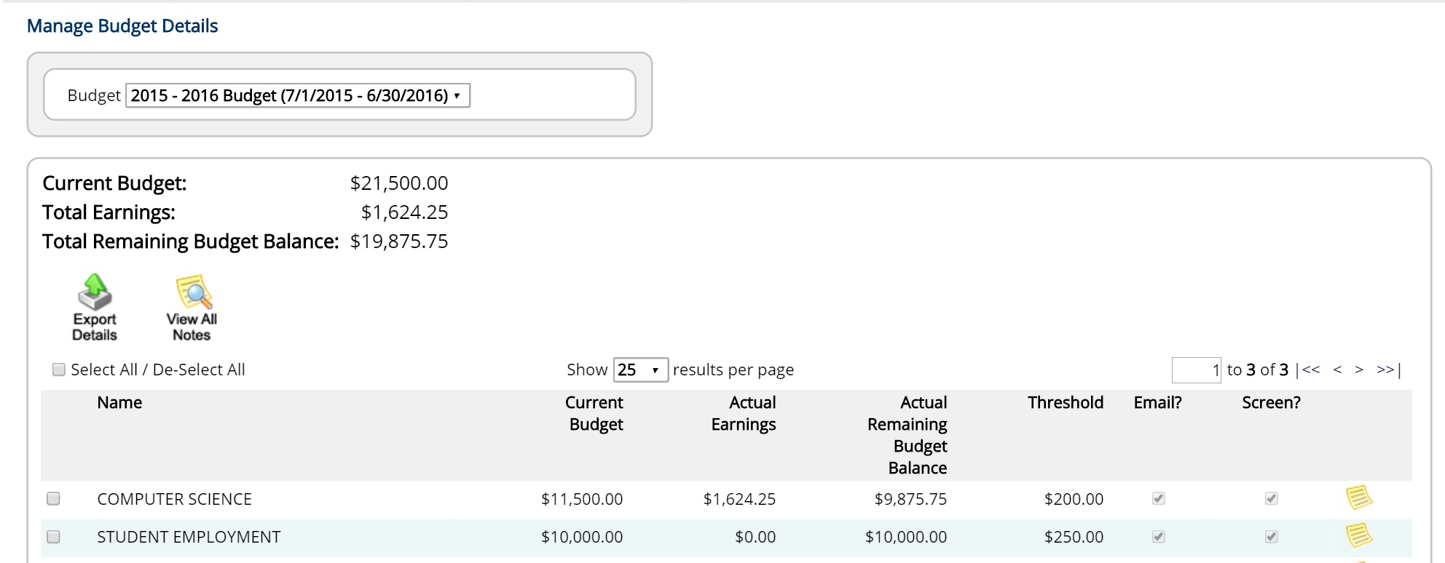
Budget Manager – Budget Dashboard

In order to further examine your cost center/departmental budget information, navigate to the TimesheetX menu and click the Budget Dashboard function. Select the current budget period you wish to review from the Budget drop down list.

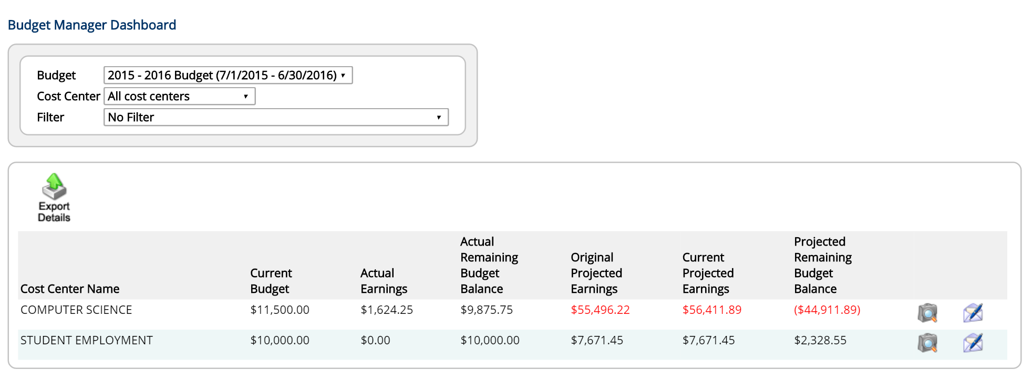

 This screen will present the following departmental budget information:
- Current Budget: The current allocated budget amount for the department.

- Actual Earnings: Actual earnings are calculated from finalized time sheets within the current budget period selected.

- Actual Remaining Budget Balance: The ‘Actual Remaining Budget Balance’ is calculated by subtracting Actual Earnings from Current Budget Amount.

- Original Projected Earnings: The Original Projected Earnings calculates the sum of all potential earnings (by multiplying wages by maximum hours per week) for all hires in all jobs, within the current budget period selected for the cost center/department.

- Current Projected Earnings: The Current Projected Earnings is calculated by adding the maximum potential earnings from time sheets within the current budget period, and not yet finalized, to the amount already finalized/paid. Time sheets that have been dismissed are not included in this calculation.

- Projected Remaining Budget Balance: The Projected Remaining Budget Balance is calculated by subtracting Current Projected Earnings from the Current Budget Amount for the cost center/department.

Please Note: If you should need the definition provided above for each column on the screen above, simply hover over the column heading and the definition will be presented.

To drill down at a cost center/departmental level to examine budget data at a job, hire, and time sheet level, simply click on the magnifying glass to the far right.

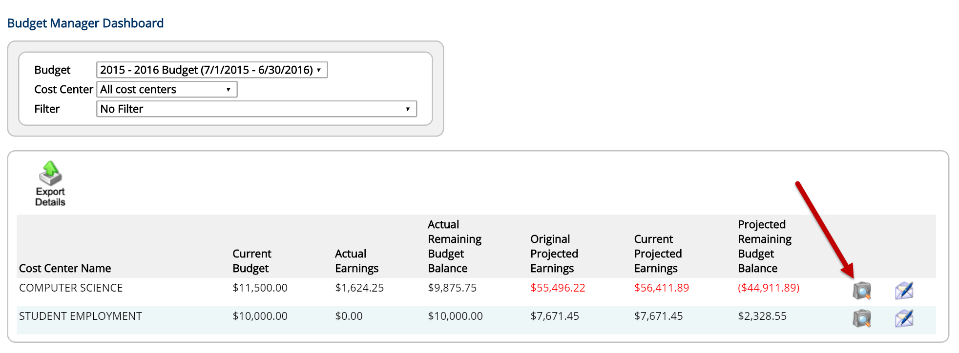

This view will enable you to see the Original Projected Earnings, Current Projected Earnings and Actual Earnings at a job level for that cost center/department.

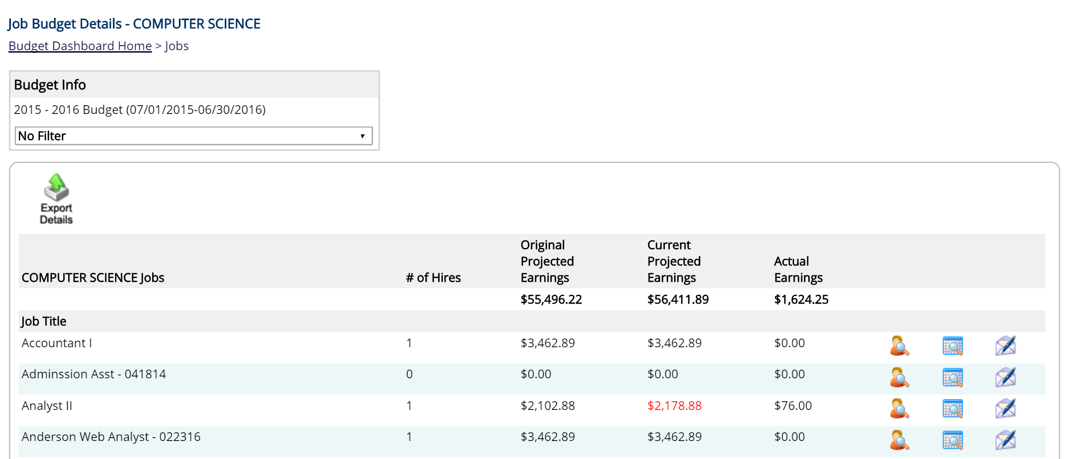

To drill down at a cost center/departmental level to examine hire earnings for the job, simply click on the magnifying glass to the far right.

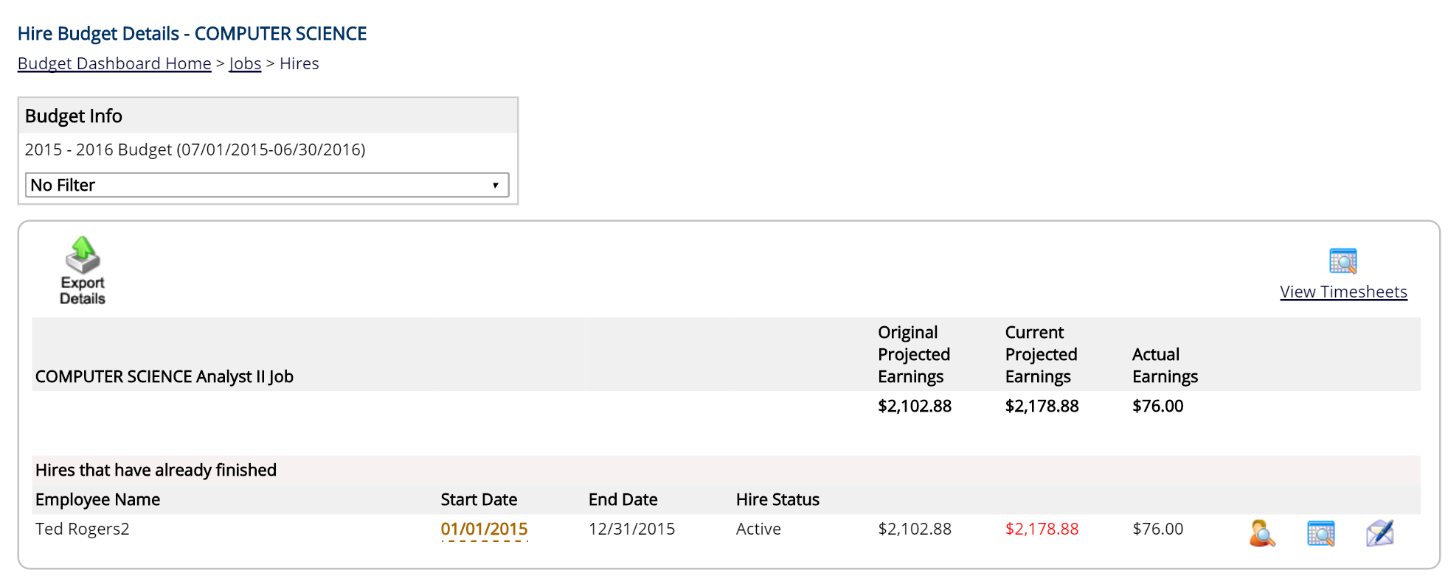

This view will enable you to see the Original Projected Earnings, Current Projected Earnings and Actual Earnings at a hire level for that job within that cost center/department.

To further drill down into the earnings of a specific hire either click on the person with a magnifying glass to the right to see the employee’s hire details or the time sheet with a magnifying glass to see their time sheet details.

Earnings Details – Hire Details
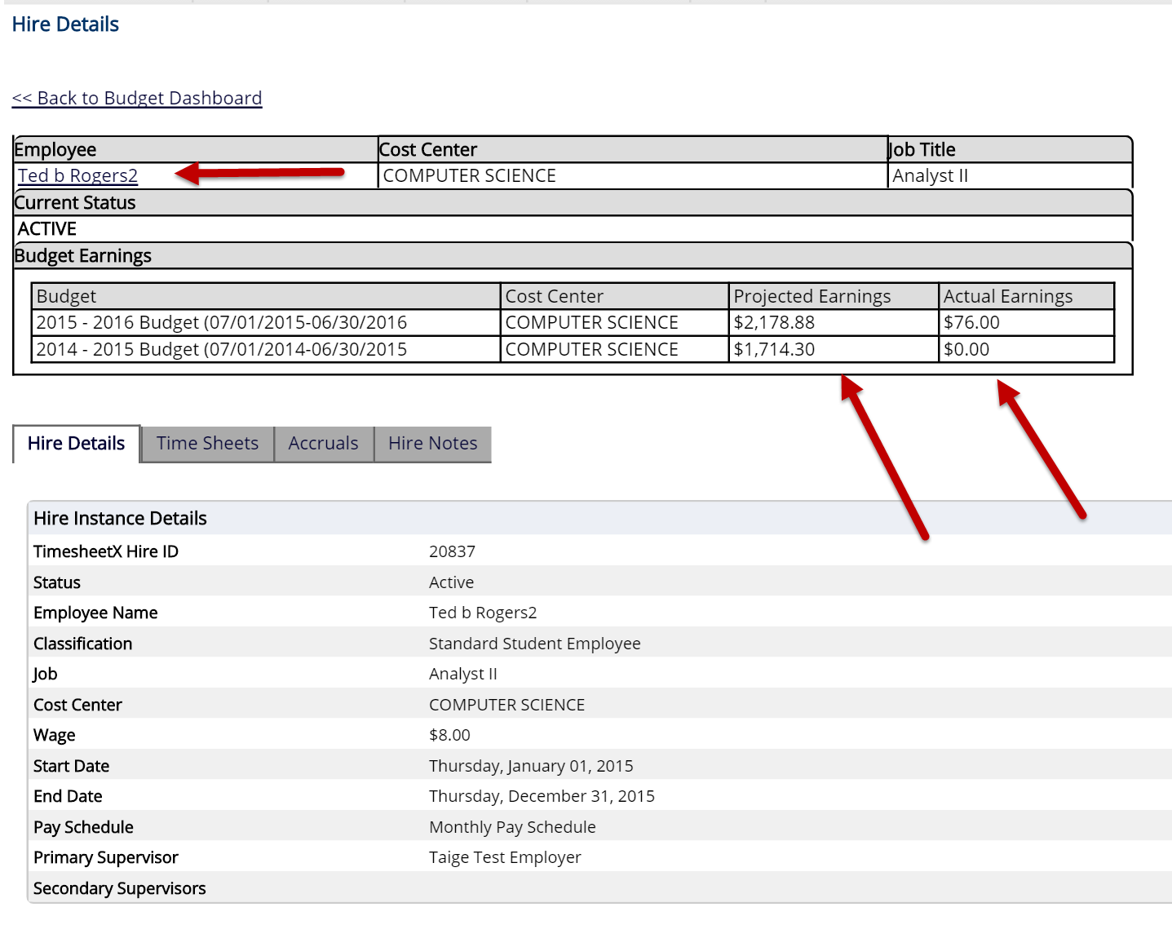

Earnings Details - Time Sheets


